Proposed Dashboard Structure for DriveLog Investigation (Connected Vehicles)

Drawing parallels from robust aviation safety analysis and adapting it for connected vehicles, our proposed dashboard aims to provide actionable insights into near-miss events. The focus will be on identifying patterns, high-risk scenarios, and potential contributing factors to enhance vehicle safety.

Note: Please note that realizing these features will depend upon data availability/veracity.

# Overall Dashboard Approach:

* **Proactive Safety:** Shift from reactive crash investigation to proactive near-miss prevention.
* **Data-Driven Insights:** Leverage connected vehicle data to identify trends and anomalies.
* **User-Centric Design:** Intuitive and interactive visualizations for various stakeholders (safety analysts, engineers, fleet managers).
* **Aviation Parallel:** Emphasize "Flight Data Monitoring" principles adapted for ground vehicles.

# Dashboard Sections and Key Visualizations:

## 1. Executive Summary / Overview (High-Level Trends)

* **Purpose:**

Provide a quick snapshot of overall near-miss activity and key performance indicators (KPIs).

* **Visualizations:**
  + **Total Near-Miss Events:** Card showing the total count of log_data_id events over a selected period.
  + **Trend of Events:** Line chart showing near-miss events over time (daily, weekly, monthly) to identify increasing/decreasing trends.
  + **Top 5 trigger_source_event Types:** Bar chart showing the most frequent types of near-miss triggers (e.g., TRIG_AEB_WARNING_MSG, TRIG_LANE_DEPARTURE).
  + **Top 5 VINs by Event Count:** Bar chart identifying vehicles with the highest frequency of near-misses.
  + **Overall Severity Distribution:** Pie/Donut chart (once thresholds are defined) showing the distribution of near-misses by severity (e.g., minor, moderate, severe based on G-forces, time-to-collision).
  + **Sample**

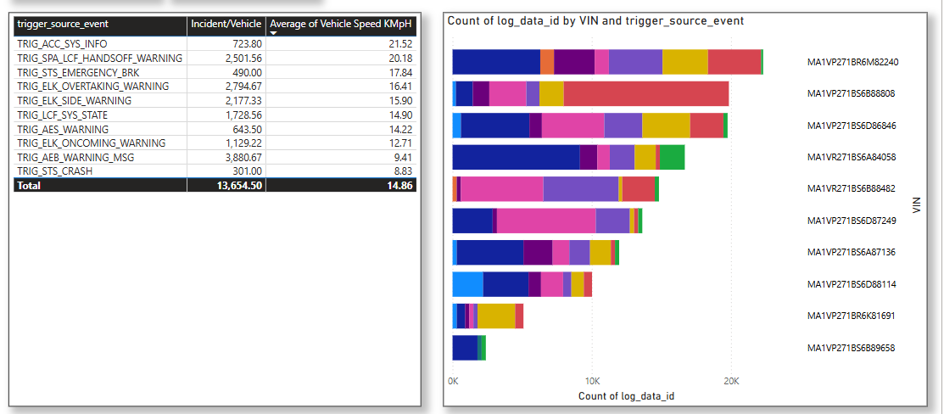

## 2. Event Details & Reconstruction (Deep Dive into Individual Events)

* **Purpose:**

Allow users to select a specific log_data_id event and visualize its dynamics. This is where the time-series data comes into play.

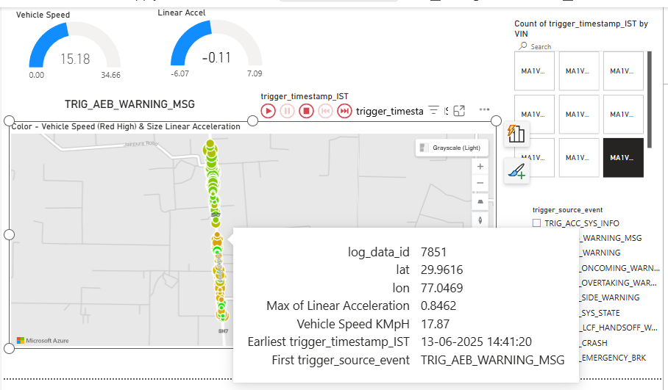

* **Visualizations:**
  + **Event Selector:** Dropdown/list to select a specific VIN and log_data_id.
  + **Time-Series Plots:**
    - **Speed Profile:** Line chart showing gps_spd over the event window (e.g., -20s to +10s relative to trigger).
    - **Acceleration Profiles:** Separate line charts for accx, accy, accz (longitudinal, lateral, vertical G-forces) over the event window.
    - **Gyroscope Profiles:** Separate line charts for gyrox, gyroy, gyroz (roll, pitch, yaw rates) over the event window.
    - **ADAS Signal Status:** Stacked area or step chart showing the activation status/values of key ADAS signals (e.g., AEB_TIME_TO_COLLISION, LANE_DEPARTURE_WARNING) over the event window.
  + **Event Context Summary:** Table or cards displaying the trigger_source_event, trigger_timestamp_IST, and any available contextual data (e.g., road conditions, weather, if available).

## 3. Pattern Analysis & Contributing Factors (Identifying Common Scenarios)

* **Purpose:**

Aggregate data to identify common patterns, high-risk locations, and specific behaviors.

* **Visualizations:**
  + **Near-Miss Distribution by Time of Day/Week:** Bar chart or heatmap showing when events are most likely to occur.
  + **Geographical Hotspots (Map Integration):** Map visualization using lat and lon to pinpoint high-risk locations or road segments. Clusters of events would indicate hotspots.
  + **Correlation Matrix/Heatmap:** (Advanced) Visualizing potential correlations between different signals or contextual factors and near-miss occurrences (e.g., high lateral G-forces often precede lane departure warnings).
  + **Driver Behavior Insights:** (If driver ID available) Analysis of near-miss frequency per driver, or common precursor behaviors identified from sensor data (e.g., sudden braking, aggressive steering).
  + **Vehicle System Anomaly Detection:** (If specific ADAS data is available) Trends in ADAS warnings that did *not* lead to intervention, or unusual signal values preceding events for specific vehicle models.

## 4. ADAS Effectiveness & Intervention Analysis (Evaluating Safety Systems)

* **Purpose:**

Assess how well ADAS systems are performing in mitigating near-misses.

* **Visualizations:**
  + **ADAS Warning vs. Intervention Rate:** Bar chart showing the ratio of ADAS warnings to actual interventions (e.g., AEB warnings vs. AEB activations). We need inputs on Signals and Physical_values to do this.
  + **Severity Reduction Post-Intervention:** (Requires more data and thresholds) A comparison of event severity when ADAS intervened versus when it did not.
  + **False Positive/Negative Analysis:** (If ground truth data is available) Identifying instances where ADAS warnings were unwarranted or where a warning was expected but not issued.(From Test Simulations)

This structure provides a comprehensive approach to near-miss investigation, moving from an overall understanding to detailed event reconstruction and pattern identification, with a strong emphasis on leveraging the connected vehicle data for proactive safety improvements.